Portland Chapter

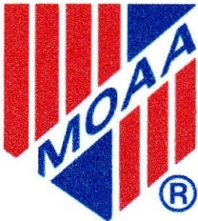
Military Officers Association of America PO Box 18206
Portland, OR 97213

APPLICATION FOR SURVIVING SPOUSE MEMBERSHIP

DATE _________________ SPONSOR: ____________________

FIRST NAME: LAST NAME: ___________

SPOUSE’S RANK: ____________ SERVICE: ________ DATE OF DEATH: ____________

ADDRESS: _____________________________________________________________

CITY: _______________________ STATE: ____________ ZIP: ________________

TELEPHONE: Home: ___________________ Cell: ___________________________

E-MAIL ADDRESS: ______________________
(Will include in Chapter Directory) ARE YOU A NATIONAL MOAA MEMBER? YES NO _________________________
LEVEL: BASIC ______ PREMIUM ______ LIFE ______
NATIONAL MOAA MEMBER ID#:______________________________

NOTE: Surviving Spouse Members are not required to pay annual dues; however, they may do so
on a voluntary basis.

Chapter dues are $30.00 annually and cover the period 1 January – 31 December.

Please make check payable to: “Portland Chapter – MOAA.”

Send to: Portland Chapter - MOAA

P.O. Box 18206

Portland, OR 97213

