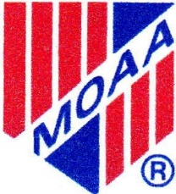
Portland Chapter
Military Officers Association of America

PO Box 18206
Portland, OR 97213
APPLICATI ON FOR REGULAR MEMBERSHIP

DATE: _________ SPONSOR:

NAME: _________________________________________________________________________
RANK: ____________________________ SERVICE: _________________________________
Retired _____________________ Former ___________________________________

SPOUSE: ______________________________________________________________________

ADDRESS: ___________________________________________________________

CITY: ___________________________ STATE: ____________ ZIP: ____________

EMAIL ADDRESS: _______________________________________________________

TELEPHONE: HOME: ___________________ CELL: _____________________________

(Will be included in the Chapter Directory)

ARE YOU A NATIONAL MOAA MEMBER? YES NO _________________________
LEVEL: BASIC ______ PREMIUM ______ LIFE ______
NATIONAL MOAA MEMBER ID#:______________________________
CIVILIAN OCCUPATION:

NOTE: Chapter dues are $30.00 annually and cover the period 1 January – 31 December.

Please make checks payable to: “Portland Chapter – MOAA.”

Send to: Portland Chapter - MOAA P.O. Box 18206

Portland, OR 97213

